How To Implement Short Term Memory Using LangGraph
An LLM has no intrinsic memory and is stateless. It does not inherently remember information from previous interactions.
Code:- Here, we aren’t using any checkpoint or persistence mechanism, so the second query has no knowledge of the first query.
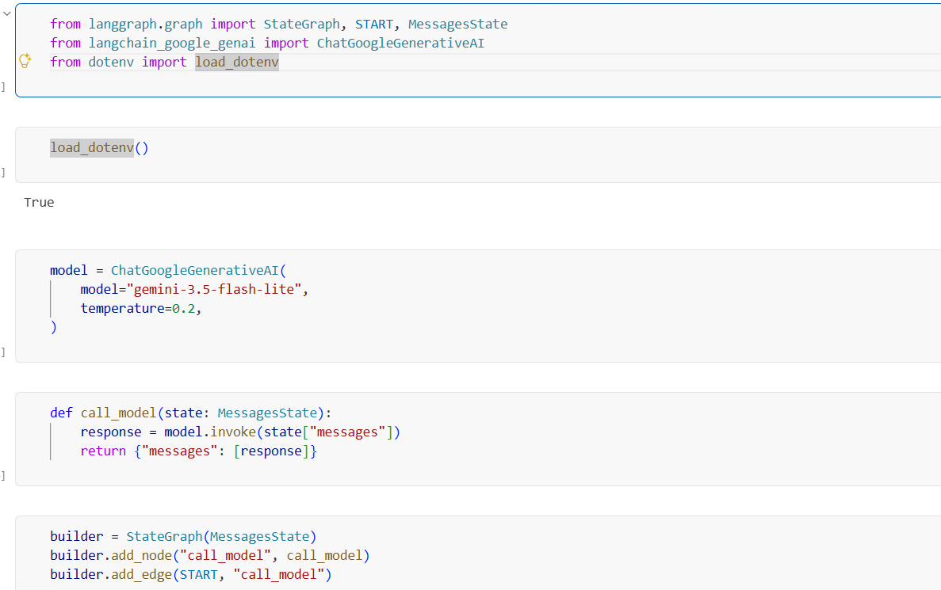
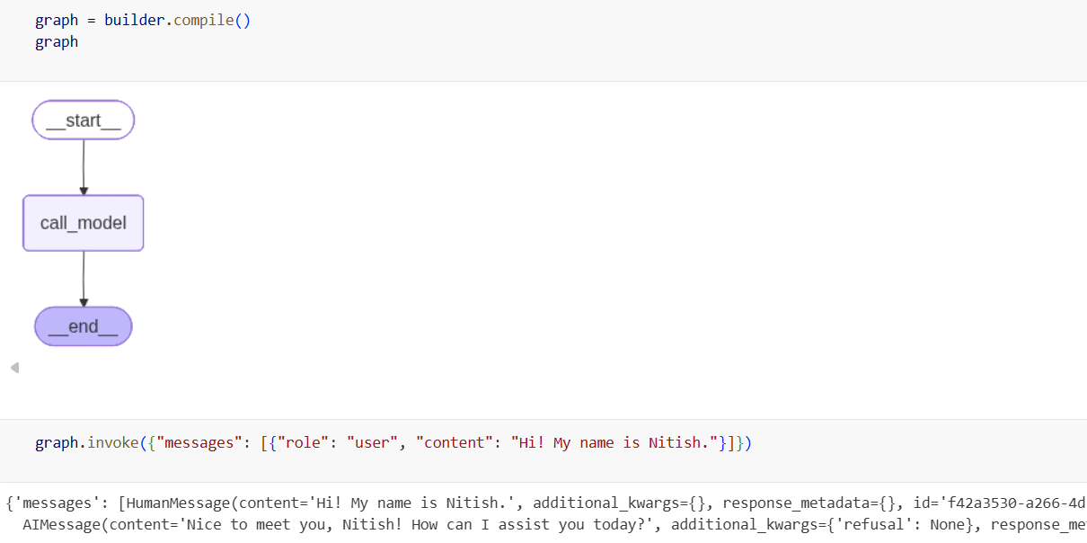
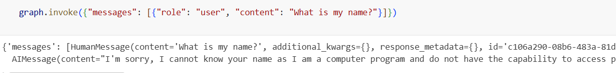
Now, we save our conversation state in RAM using InMemorySaver. We initialize InMemorySaver before compiling the graph and pass it to the compiler.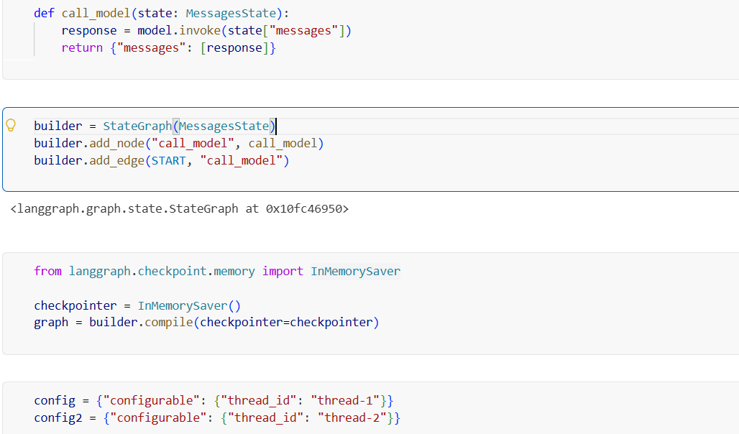
Here, the chatbot doesn’t know my name because we changed the thread ID for the second query. If we had used the same thread_id (thread-1), it would have been able to access the previous conversation state and answer correctly.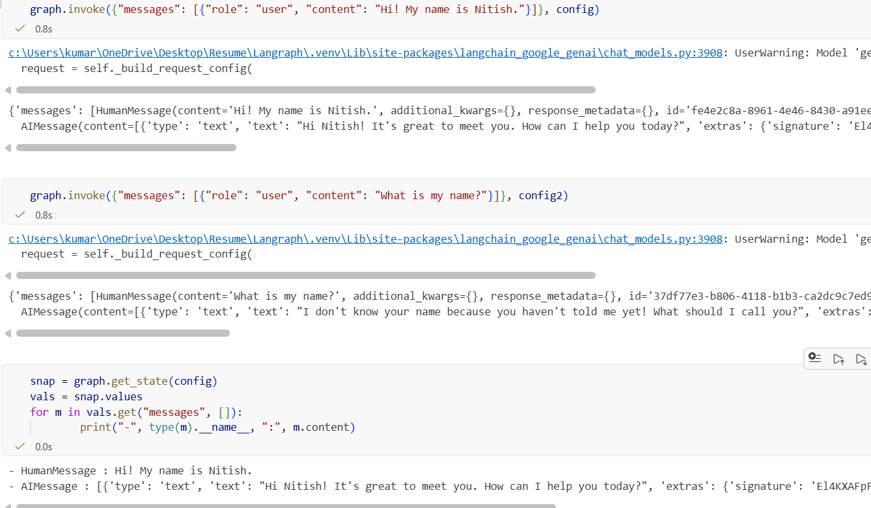

But if we restart this code then again then entire context is gone.
Solution 2 ( Persistance ) – We use postgres to store our context.
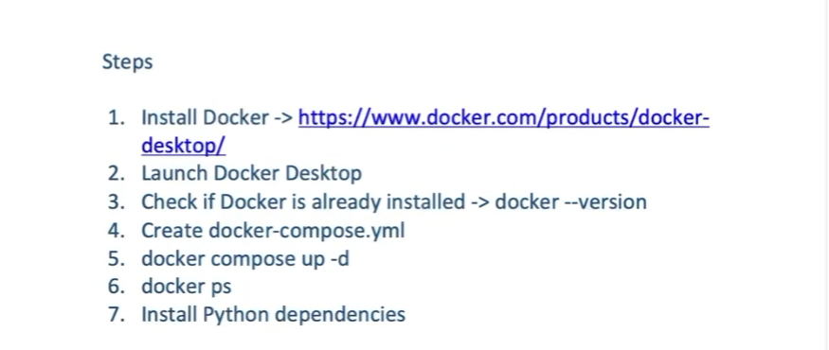

When we run this, it will install an image of postgres on our system.
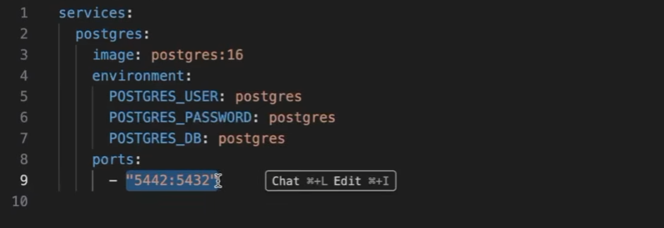
We would also install these dependencies.
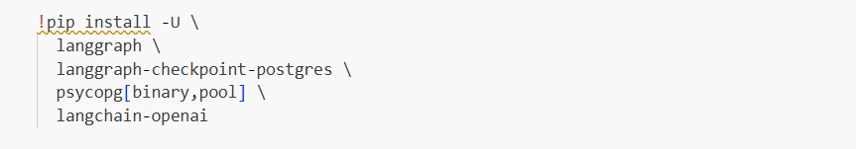
Code:- There is no change in the code; everything else remains the same.
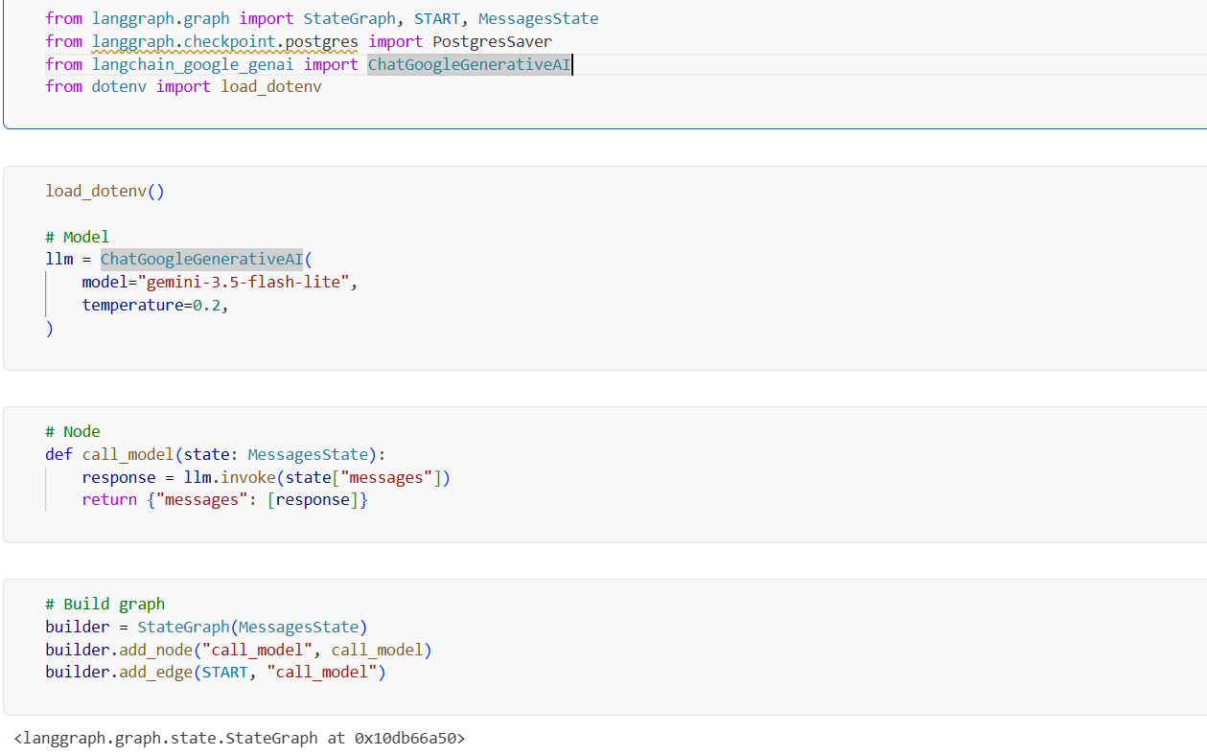

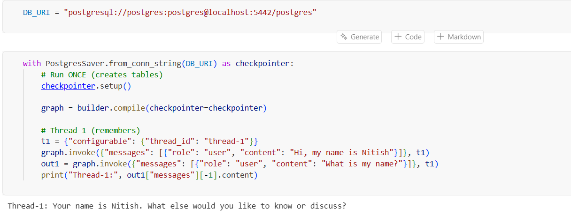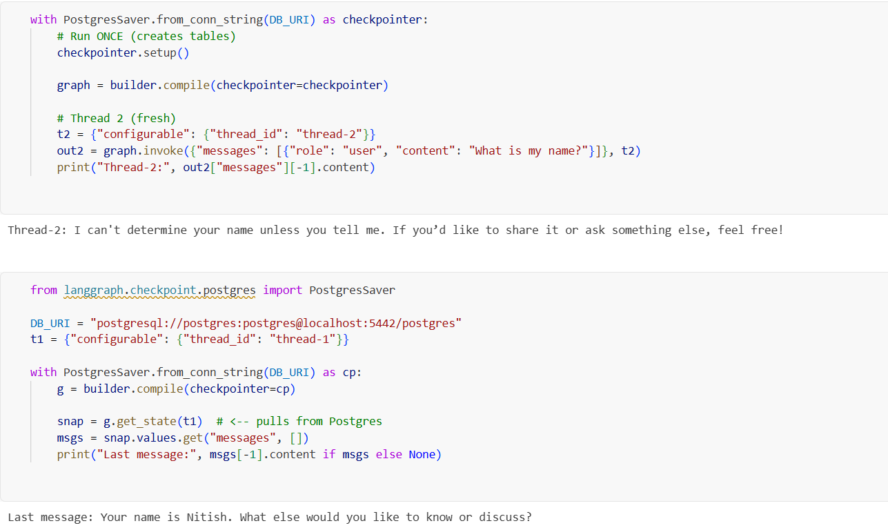

We set a maximum token limit and retain only the most recent N messages that fit within that limit. Any messages beyond this limit are trimmed from the context sent to the LLM. They are not deleted from the stored conversation; they are simply excluded when making the query.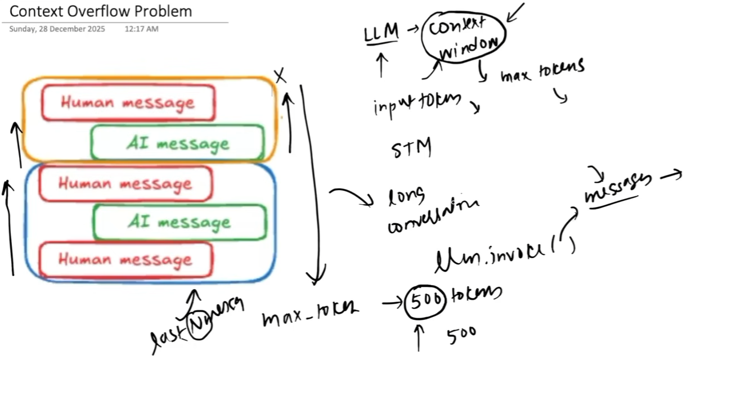
Code:-
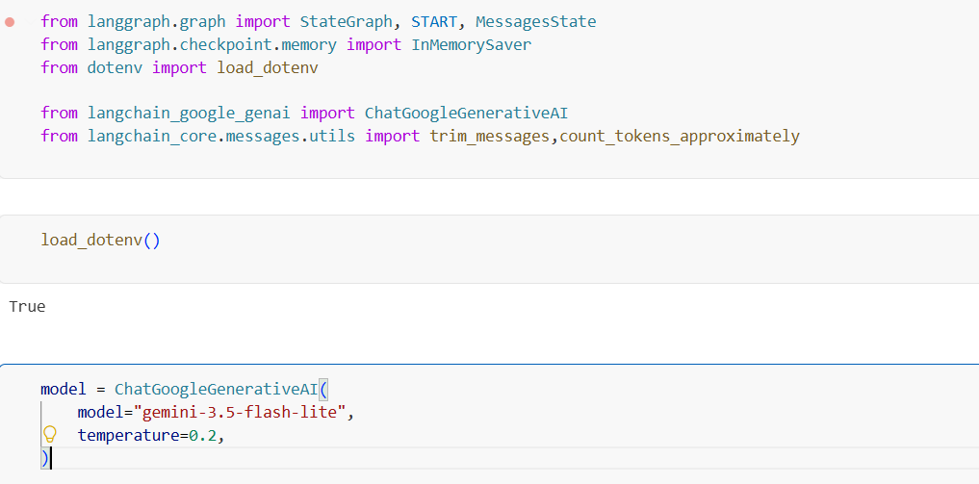

The main part of this code is that we set a maximum token limit and create a call_model node that passes the messages to the trim_messages function. This function is provided by LangChain and calculates the total token count of the messages in state["messages"]. The strategy="last" option keeps the most recent messages that fit within MAX_TOKENS. We then pass these trimmed messages to the LLM using invoke().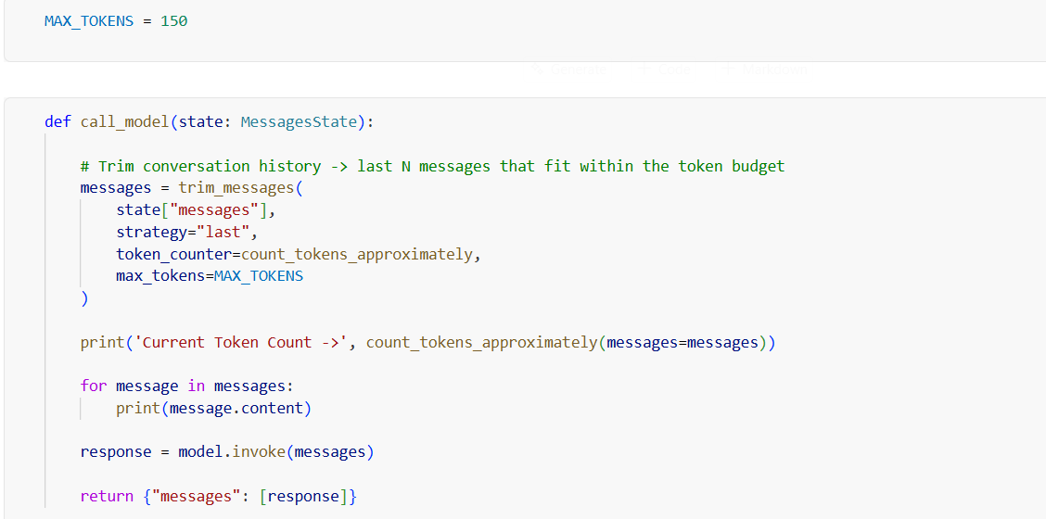

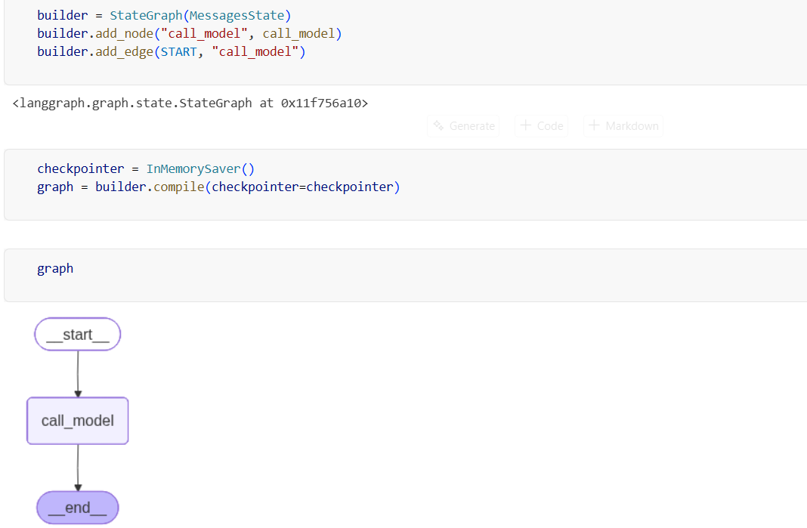
We can see that the query contains messages up to the 150-token limit that we set earlier.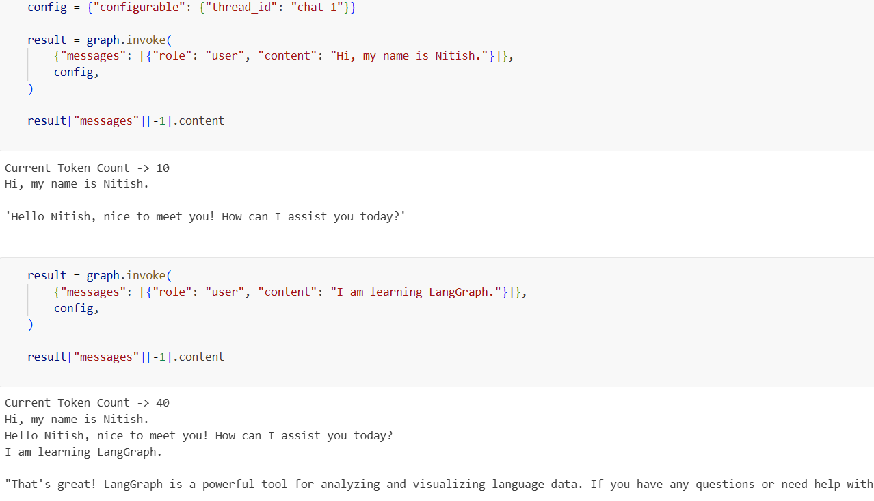

In the last query, the conversation exceeded the 150-token limit, so a significant amount of context was trimmed. The data is still stored in RAM, but we cannot send all of it to the LLM because of the token limit. Therefore, we send only a trimmed version of the conversation.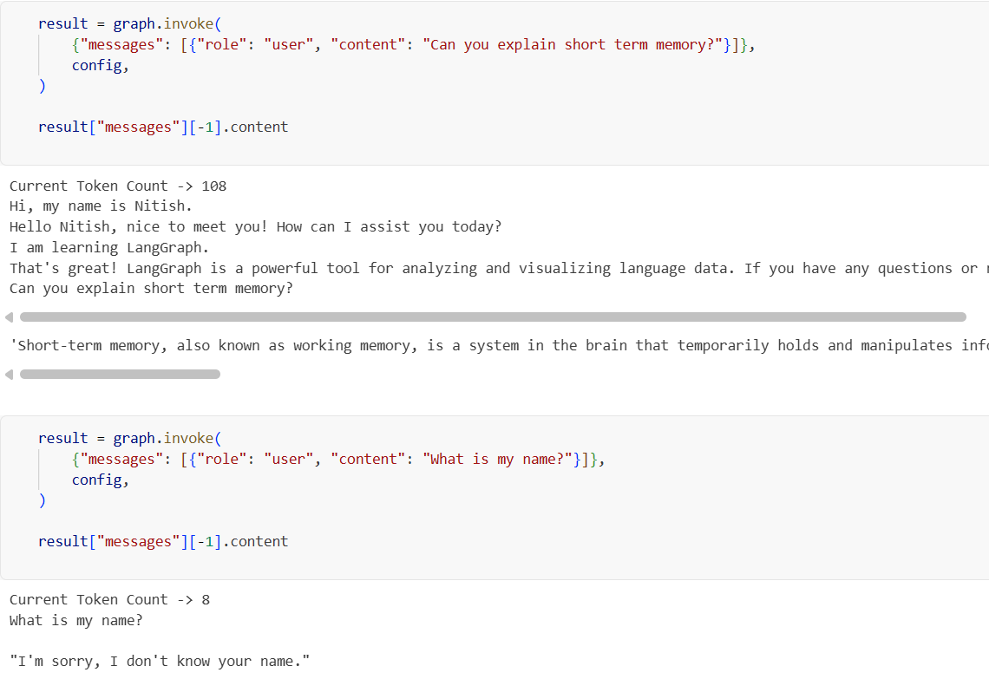

However, this approach can also remove important information. To address this, we can send the trimmed-out messages to another LLM, generate a summary, and include that summary in the query sent to the main LLM.
One important difference is that we remove the messages that have already been summarized to avoid redundancy or confusion.

Code:-
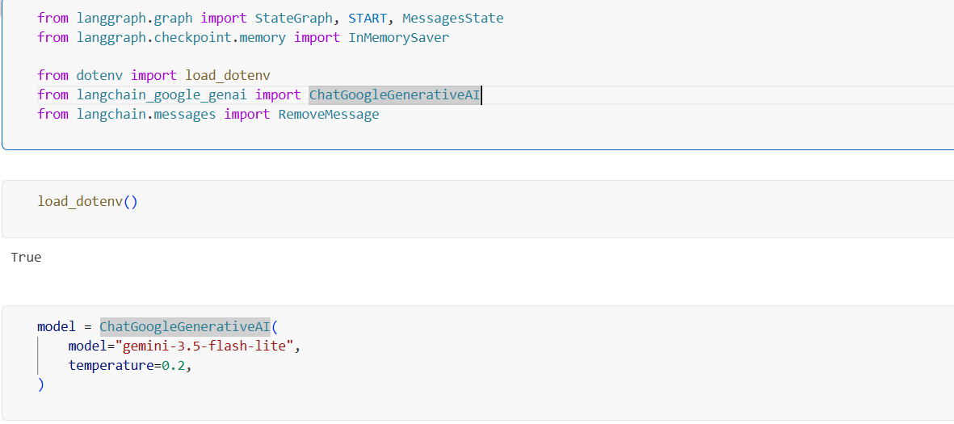
Basically, we define a rule: if there are more than 10 messages, we delete the first 6 messages.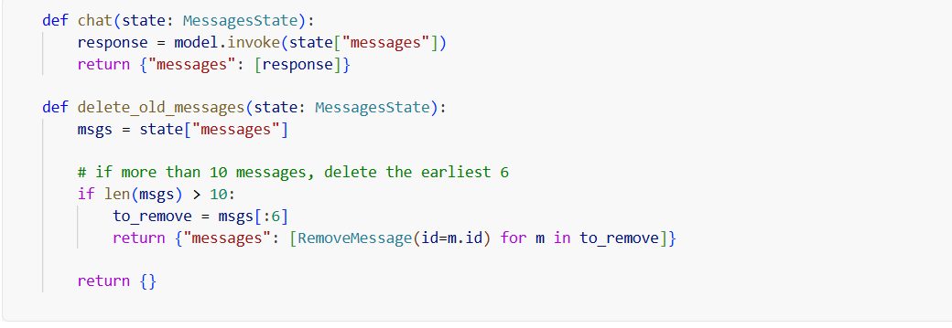
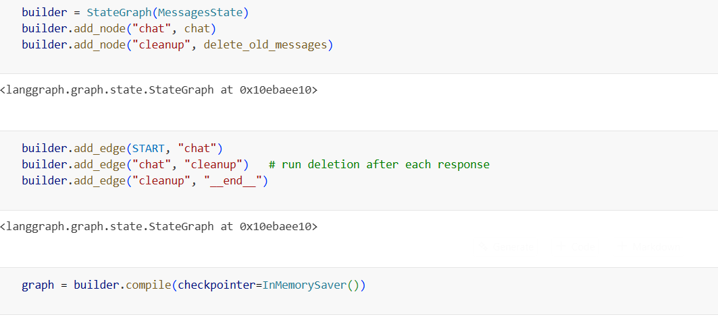
Cleanup is conditional—it is performed only when the conversation exceeds the specified message limit.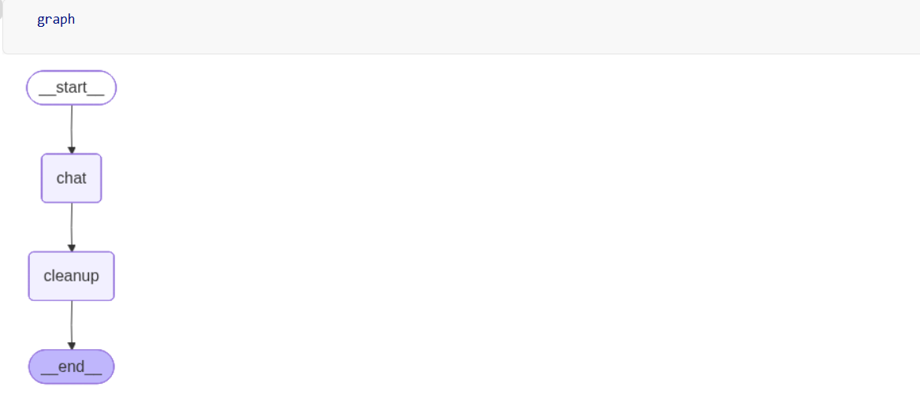
Here, we have 7 queries, and each query has a corresponding response, giving us a total of 14 messages. Since this exceeds the limit of 10, calling get_state() deletes the first 6 messages, leaving the last 8 messages, as shown in the response.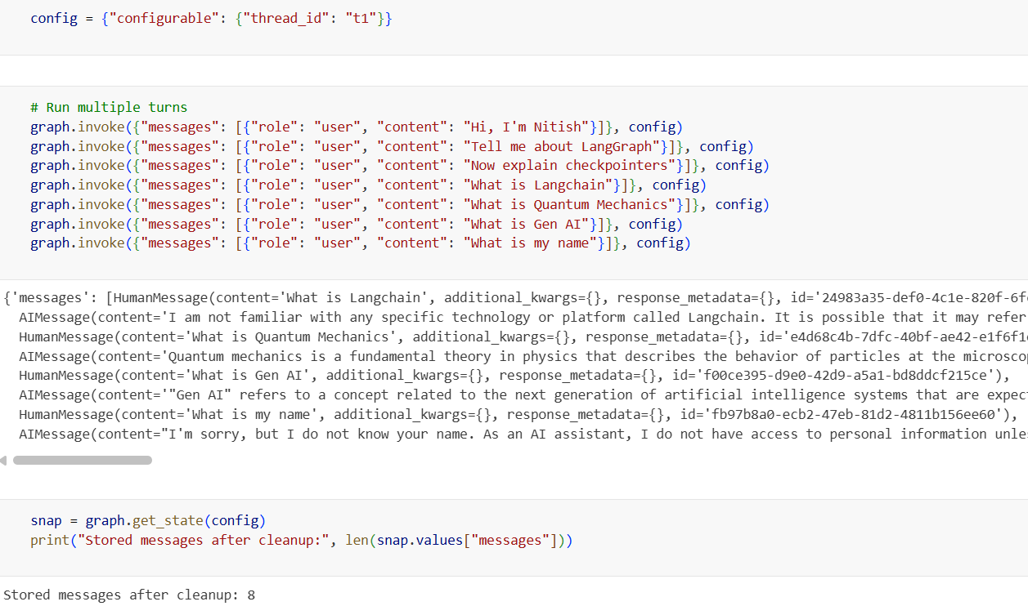

Now, we will summarize the extra messages that are going to be deleted, so that their important context is not lost.
Code:- This time, we create a state field to store the conversation summary.
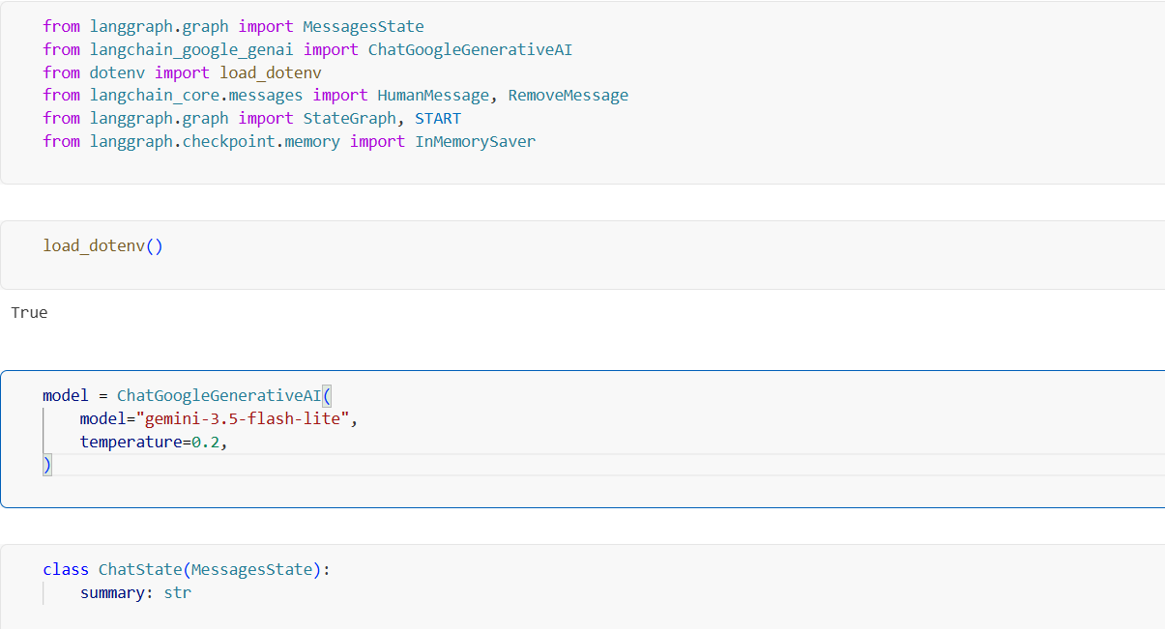
This function summarizes the conversation, stores the summary in the state, and removes older messages while keeping the last 2 messages.
Explanation:
- existing_summary = state["summary"] → Gets the existing summary from the state.
- If existing_summary exists, we ask the LLM to extend the existing summary using the new conversation.
- If there is no existing summary, we ask the LLM to create a new summary.
- messages_for_summary combines the current conversation messages with the summarization prompt.
- model.invoke(messages_for_summary) sends the conversation to the LLM and generates the summary.
- state["messages"][:-2] selects all messages except the last 2.
- RemoveMessage(id=m.id) removes those older messages from the state.
- Finally, the function returns:
  - The new/updated summary.
  - Instructions to remove the older messages.
- The last 2 messages remain available verbatim as recent context.
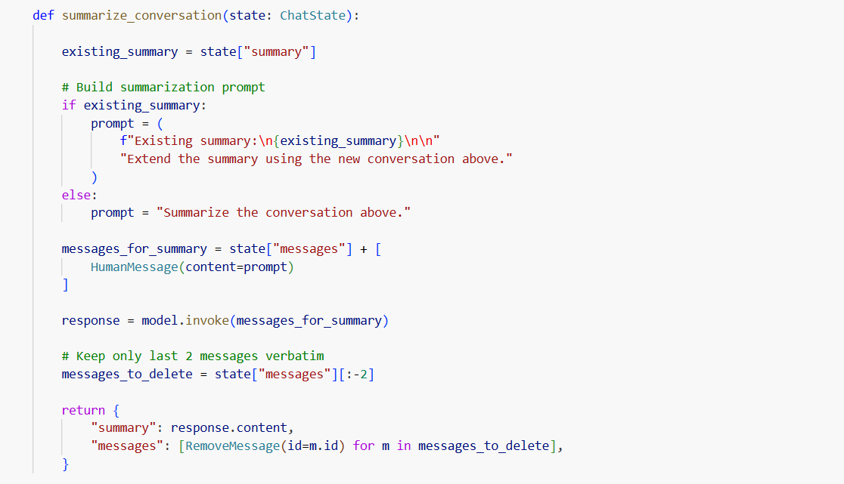
This function prepares the conversation context by combining the conversation summary and the remaining messages, sends them to the LLM, and stores the response.
Explanation:
- messages = [] → Creates an empty list to store the messages that will be sent to the LLM.
- If state["summary"] exists:
  - Adds the summary as a system message.
  - This gives the LLM the summarized information from the older conversation.
- messages.extend(state["messages"]) → Adds the remaining messages from the current conversation to the list.
- print(messages) → Prints the final messages being sent to the LLM.
- response = model.invoke(messages) → Sends the summary + remaining messages to the LLM and gets the response.
- return {"messages": [response]} → Adds the LLM's response back to the state as a new message.
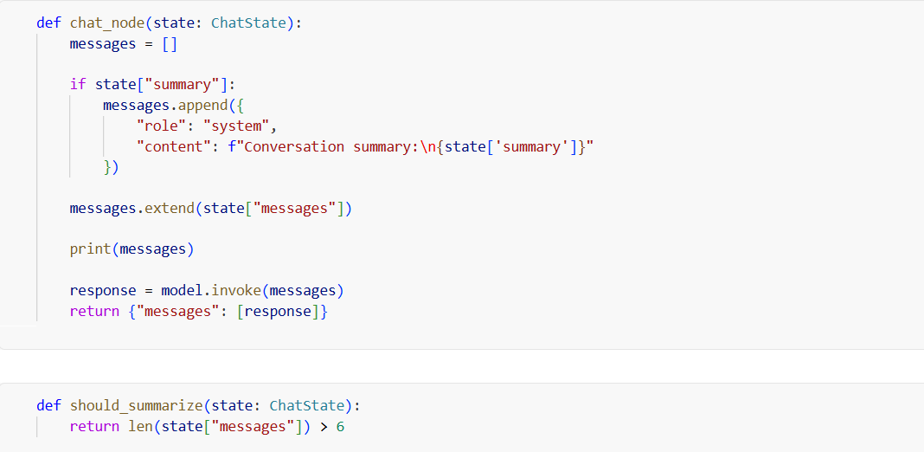

This is a basic conditional node. We use should_summarise to determine whether the conversation needs to be summarized.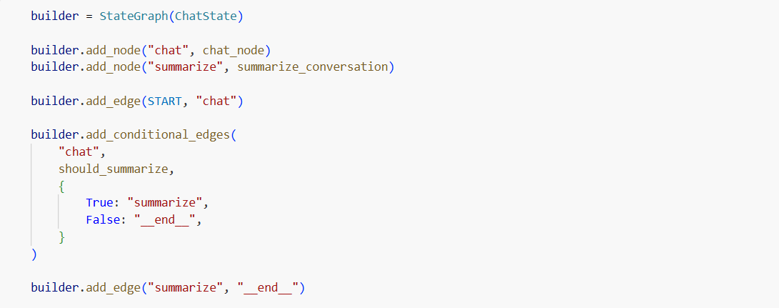
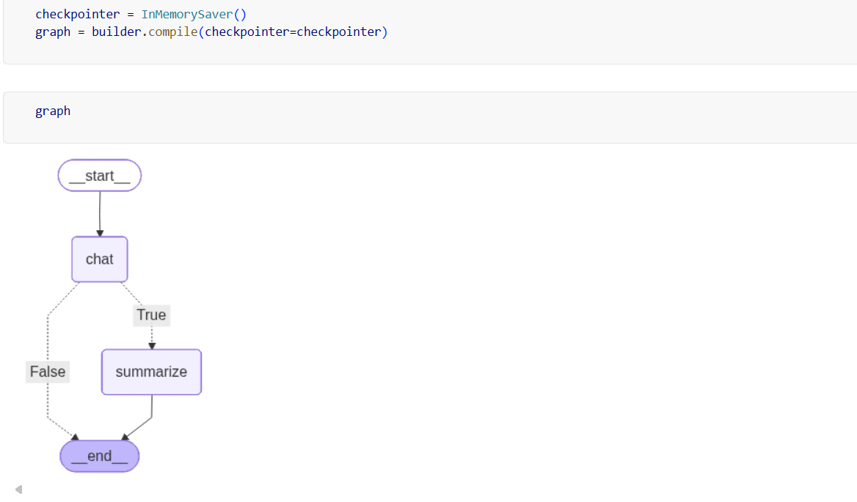
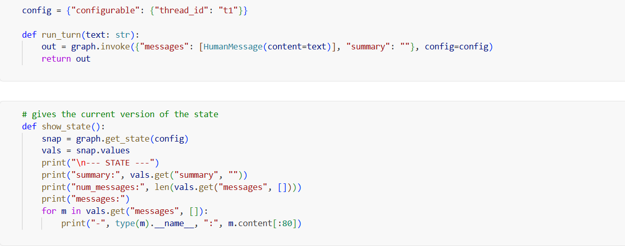

It works as expected as long as there are fewer than 6 messages.
Intuition
When the message count is below the threshold, there is nothing to summarize or delete, so the normal flow continues.
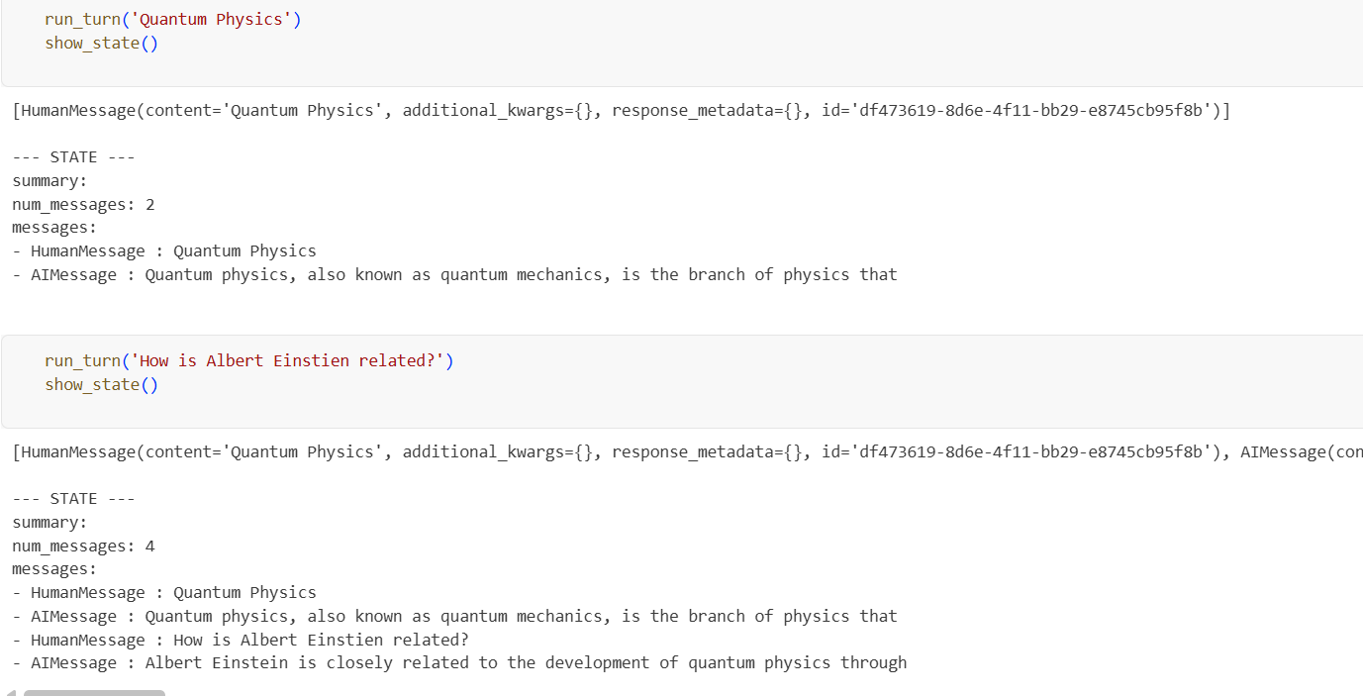
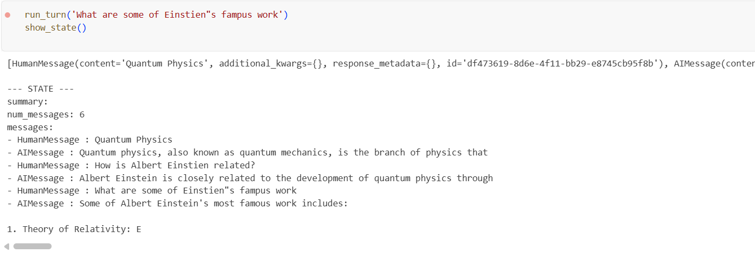
As we can see, the moment the number of messages becomes 8 (more than 6), we summarize and remove the older messages, leaving only 2 messages. The information from the removed 6 messages is now captured in the summary, while the newest 2 remain in messages.